**OUTREACH SCHOOLS EXAMINATION BOARD**

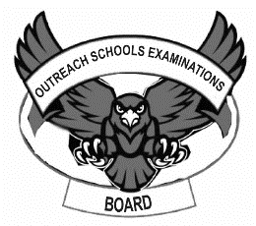 **BEGINNING OF TERM III EXAMINATION 2024**

**PRIMARY TWO**

**LITERACY II**

**My name is ___________________________________________**

**I am in ________________________________________________**

**My school is __________________________________________**

1. **Arrange sounds to form correct words.**

derspi _________________________ uebl ______________________

ckdu _________________________ izema ____________________

irdb __________________________

1. **Use the given sounds to form words.**

(a, b, c, d, e, t, o, g)

1. __________________________ iii) ___________________________
2. __________________________ iv) ___________________________
3. **Write the last sounds for these pictures.**

|  |  |  |
| --- | --- | --- |
|  |  |  |
|  |  |  |

1. **Form small words from the big words.**

elephant: ..................................... cockroach: ....................................

mosquitoes: ............................... kitchen: ........................................

footwear: ………………………..

1. **Complete the sentences using the given words in the brackets.**
2. My hen had laid an ………………………. (age, egg)
3. I am ten years ………………………. (odd, old)
4. A ………………………. eats rats at home. (cat, cut)
5. ………………………. Is a month of the year. (my, May)
6. I have ten …………………………. (fingers, figures)
7. **Fill in the puzzle correctly.**

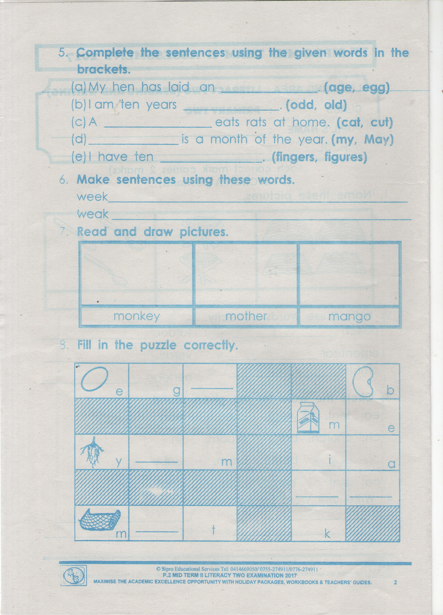

1. **Read and draw pictures.**

|  |  |  |
| --- | --- | --- |
|  |  |  |
| **mother** | **monkey** | **mango** |

1. **Read the conversation and answer the questions that follow.**

Anitah: Hullo Joan.

Joan: Hullo Anitah.

Anitah: Come and we read the books.

Joan: I don’t want to read but I want to play.

Anitah: If you don’t read books you will not pass exams.

Joan: I don’t know how to read.

Anitah: I will teach you how to read words.

Joan: Do you know how to read?

Anitah: Yes please

Joan: Let us go inside and you teach me how to read.

**Questions:**

1. …………………………. and ……………………… are talking in the conversation.
2. Who doesn’t know how to read and write?

………………………………………………………………………………

1. Who was the first to talk?

……………………………………………………………………………..

1. ……………………….. was the last to talk.
2. Read and draw.

|  |  |
| --- | --- |
| Mortar and pestle | straws |
|  |  |

1. **Copy correctly.**

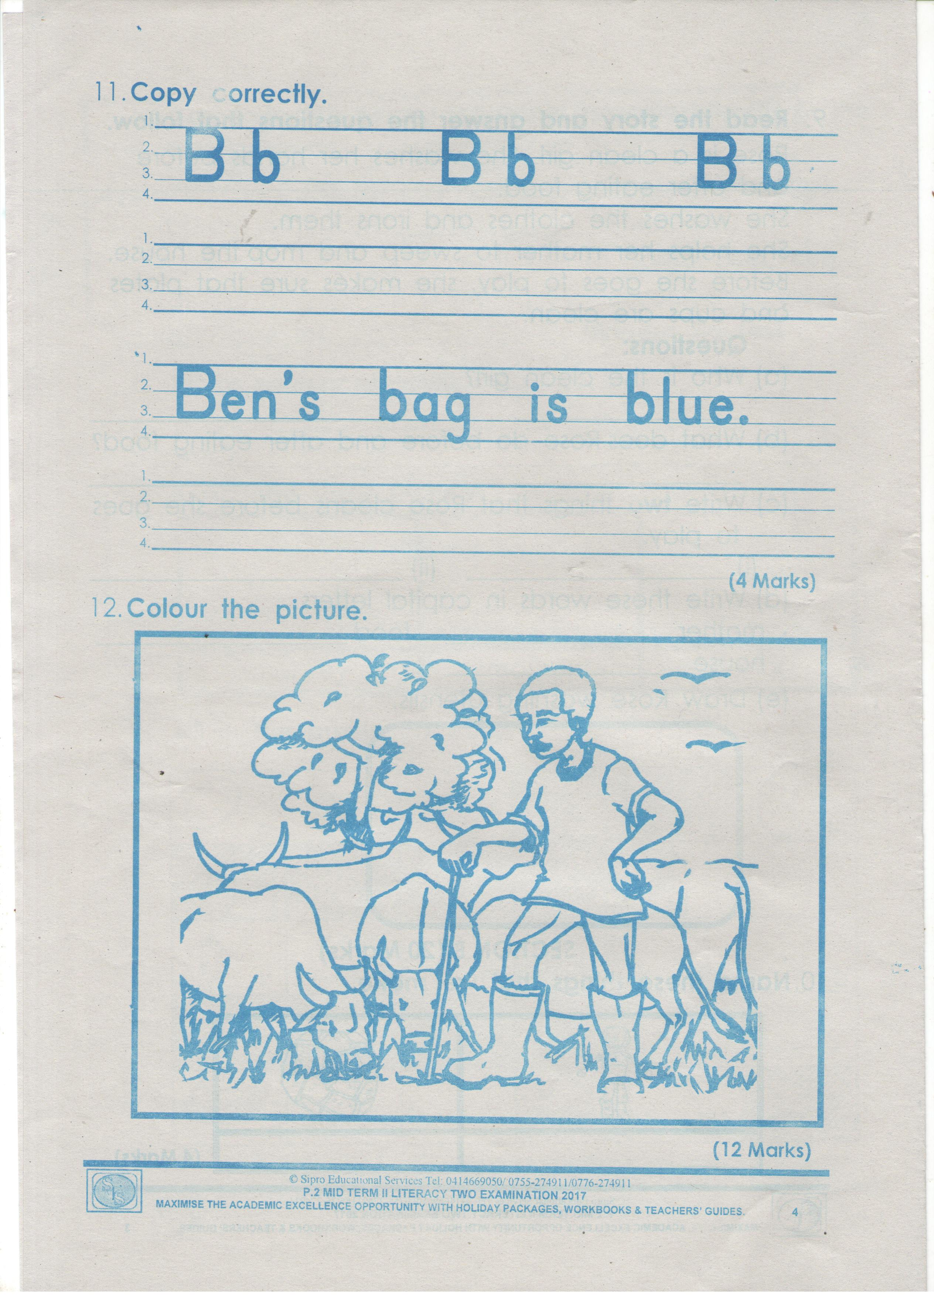

1. **Colour the picture.**



**Good Luck**